EE450

Mininet Lab Report

Yuhang Xiao

Abstract

This report investigated Mininet and iPerf3, which are virtual tools to design and test networks. The first lab explored the Mininet, which invoked Mininet from the command-line interface (CLI) utility. Then Miniedit, which is a graphical user interface (GUI) of Mininet, is used to construct, emulate and save a network topology. The second lab demonstrated how to use iPerf3 to measure and test network throughput in the designed network topology coming from the first lab. It explored the functionality of different options from the command line utility. Through this report, Mininet and iPerf3 would be known well.

Lab 1

1.

Introduction, no screenshot.

2.

2.1

Step 1.

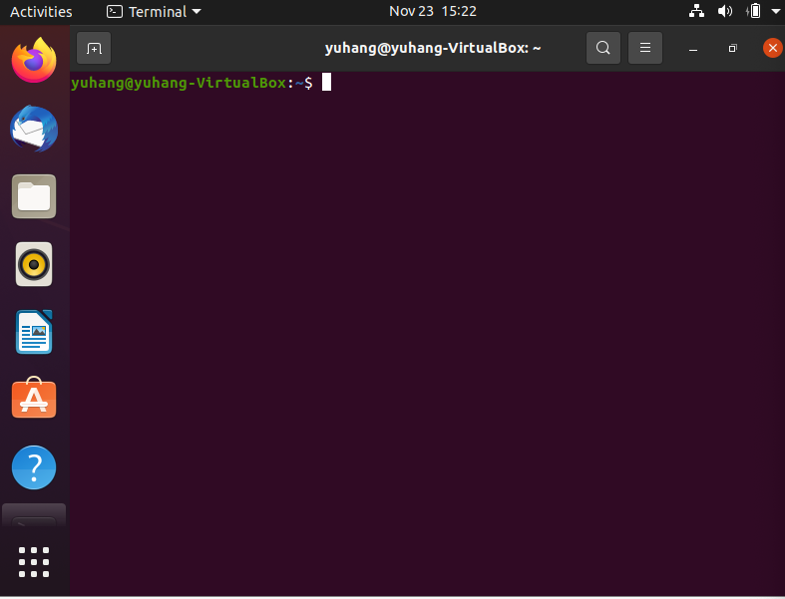

Step 2.

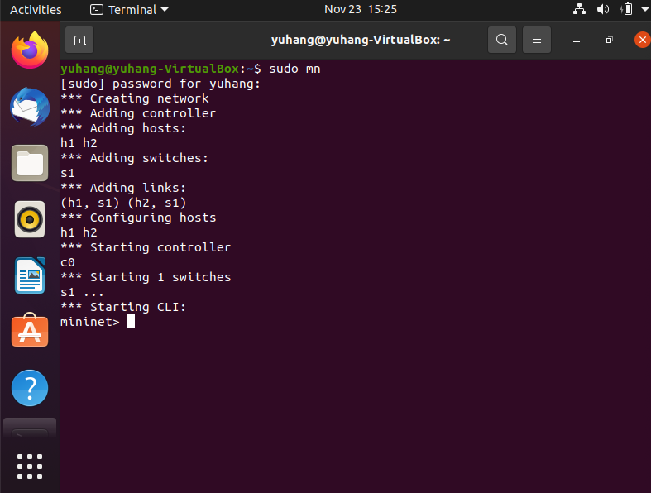

Step 3.

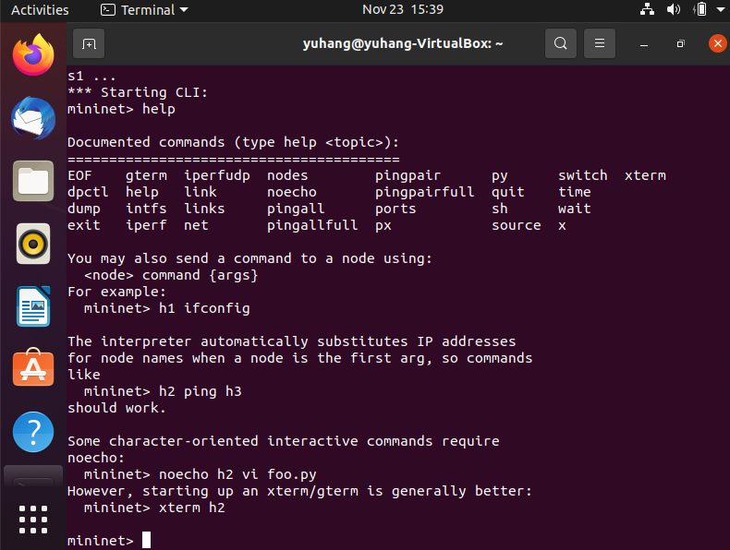

Step 4.

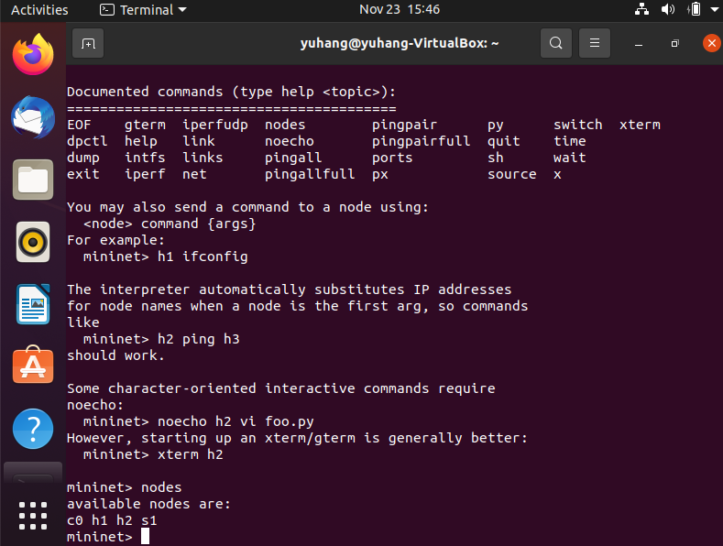

Step 5.

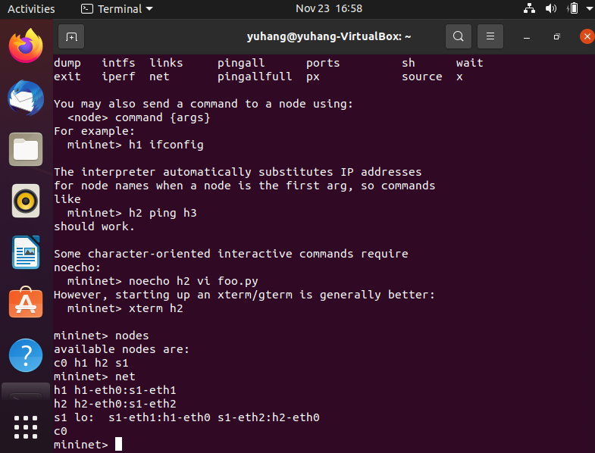

Step 6.

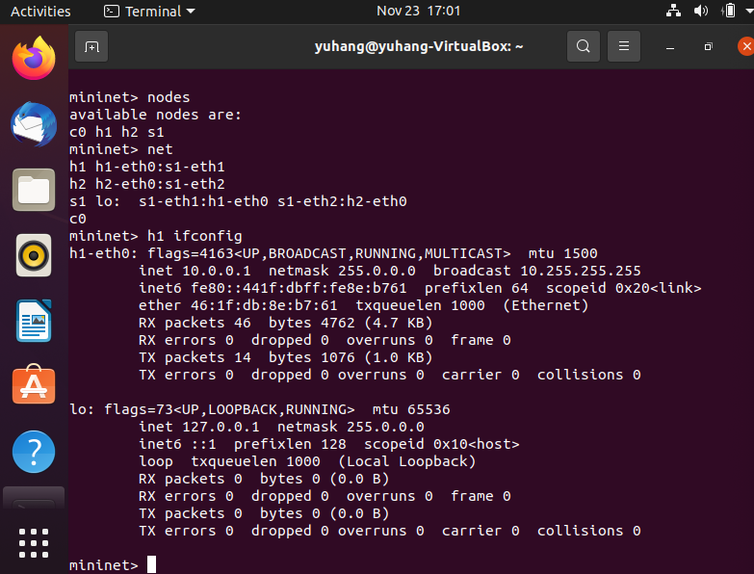

2.2

Step 1.

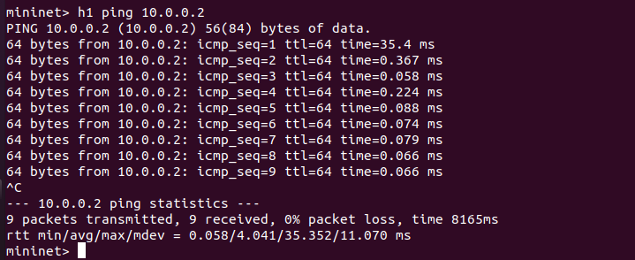

Step 2.

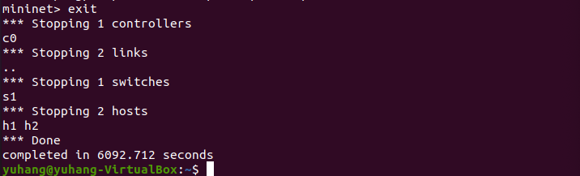

3.

3.1

Step 1.

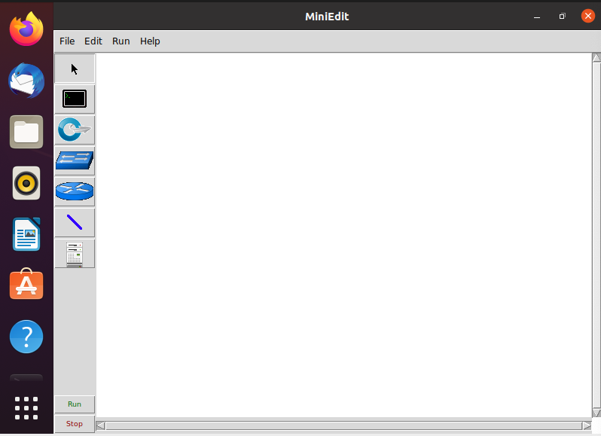

Step 2.

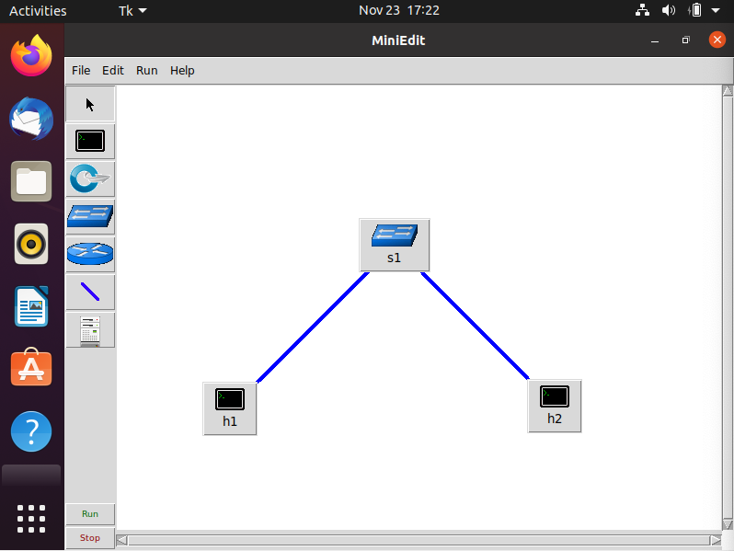

Step 3.

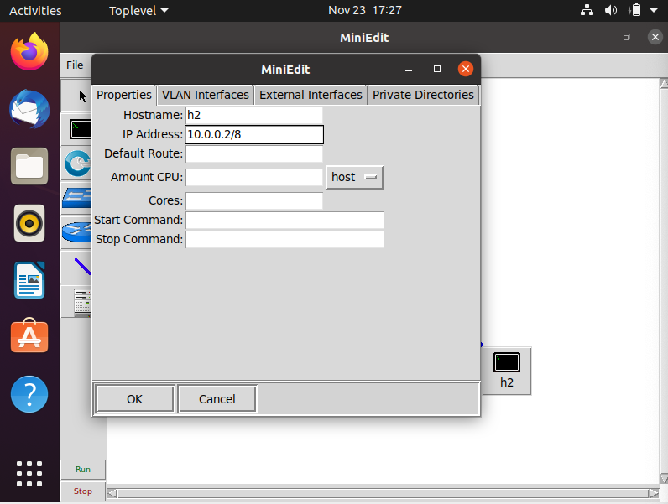

3.2

Step 1.

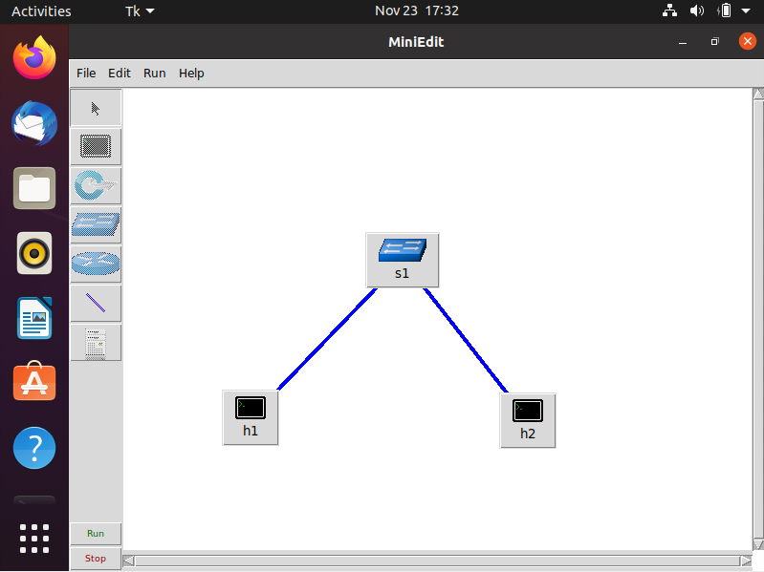

Step 2.

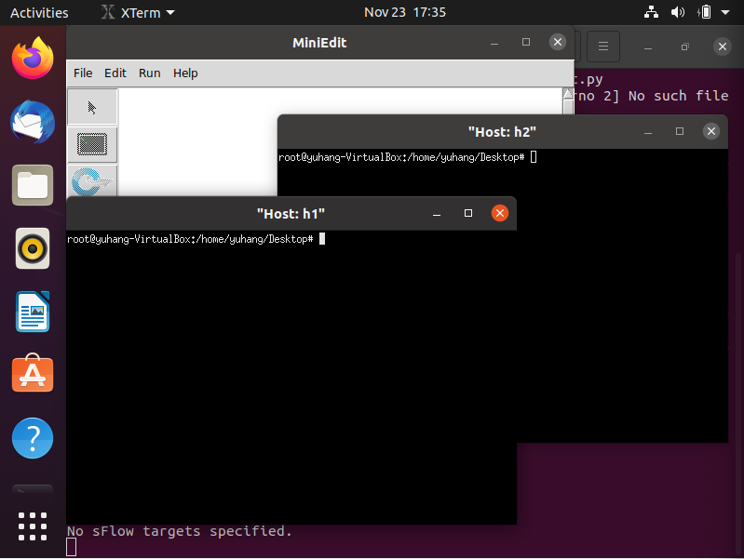

Step 3.

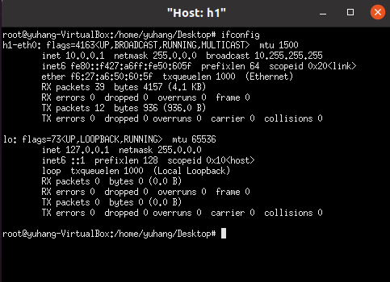

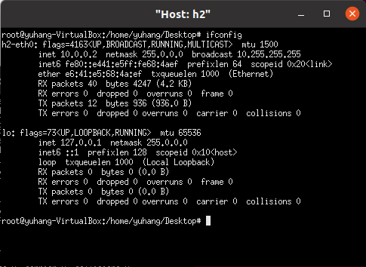

Step 4.

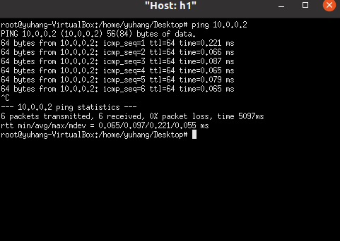

Step 5.

Stopped the emulation, no screenshot.

3.3

Step 1.

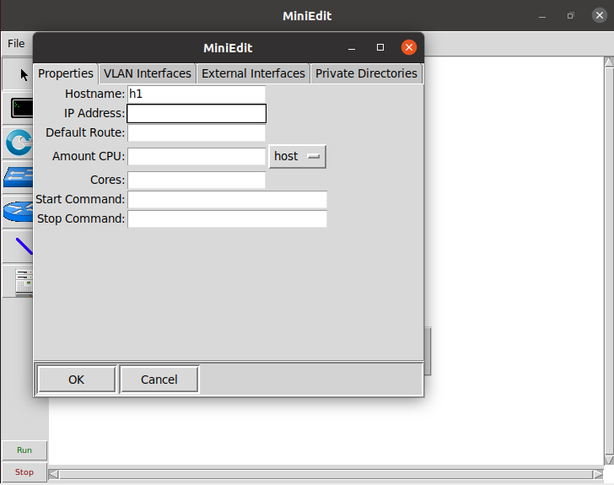 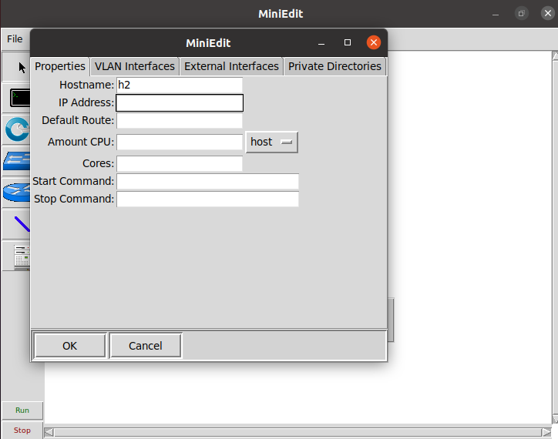

Step 2.

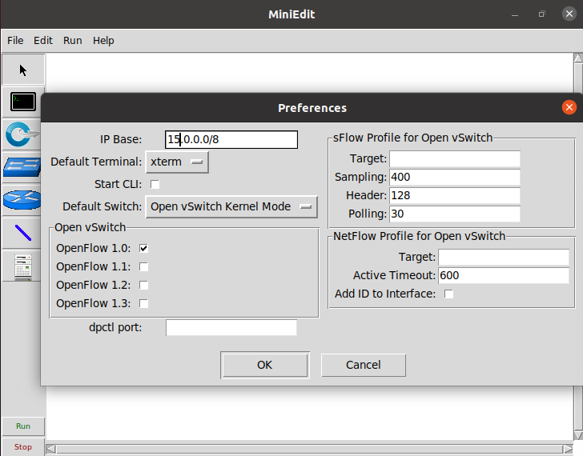

Step 3.

Run the emulation, no screenshot.

Step 4.

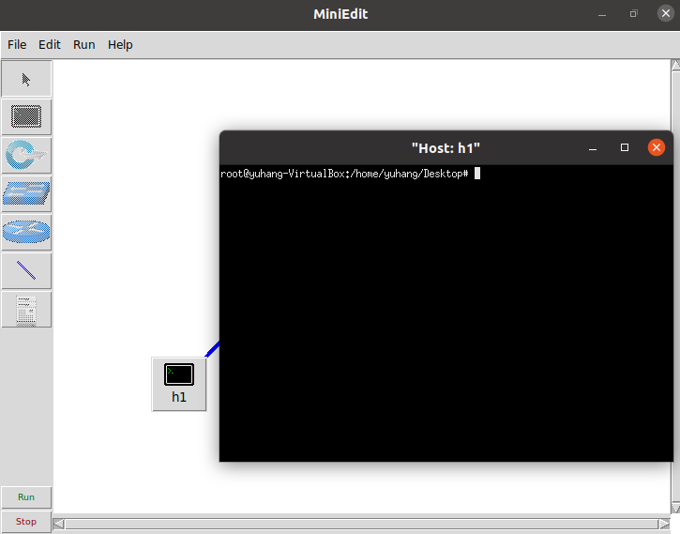

Step 5.

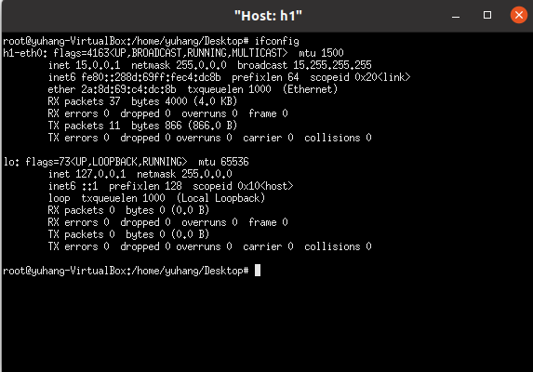

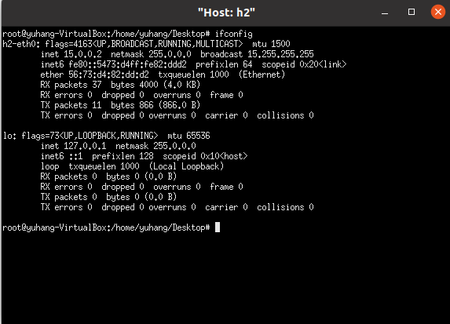

Step 6.

Stopped the emulation, no screenshot.

3.4

Step 1.

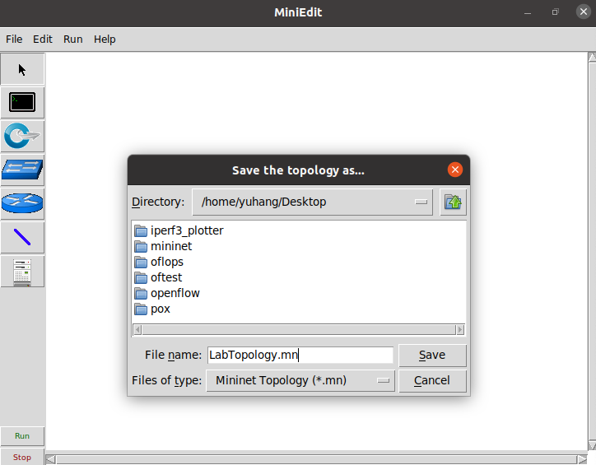

Step 2.

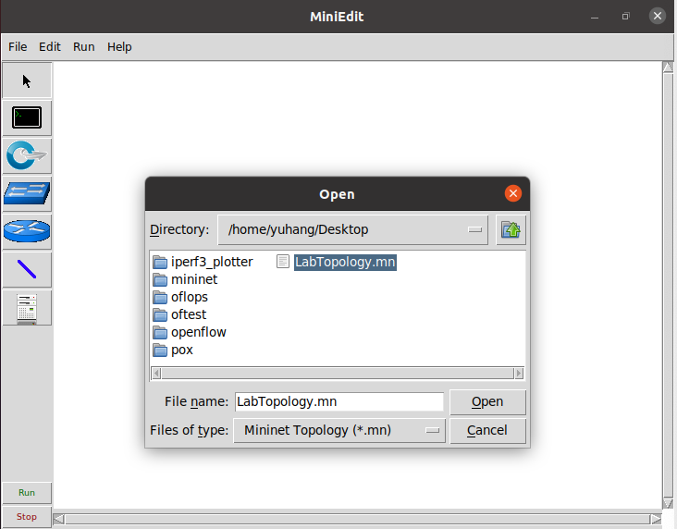

Lab 2

1.

Introduction, no screenshot.

2.

Step 1.

Start MiniEdit, no screenshot.

Step 2.

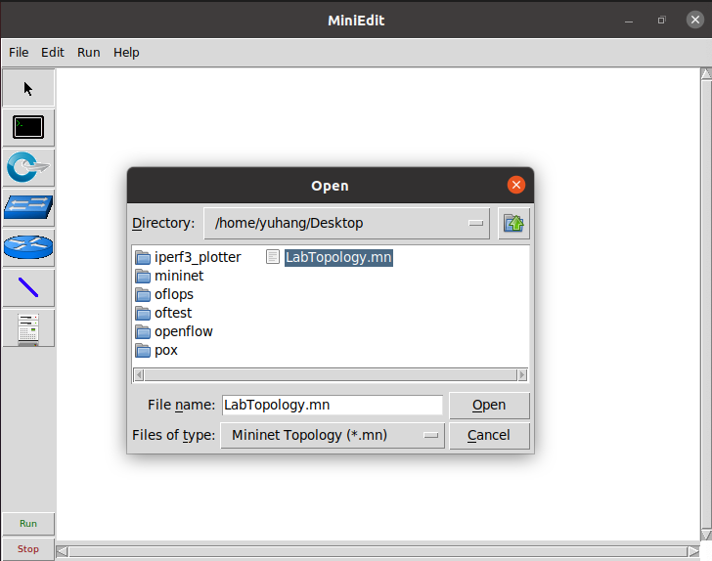

Step 3.

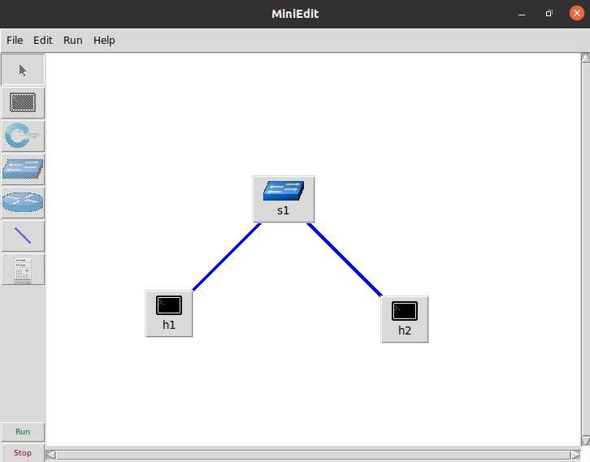

2.1

Step 1.

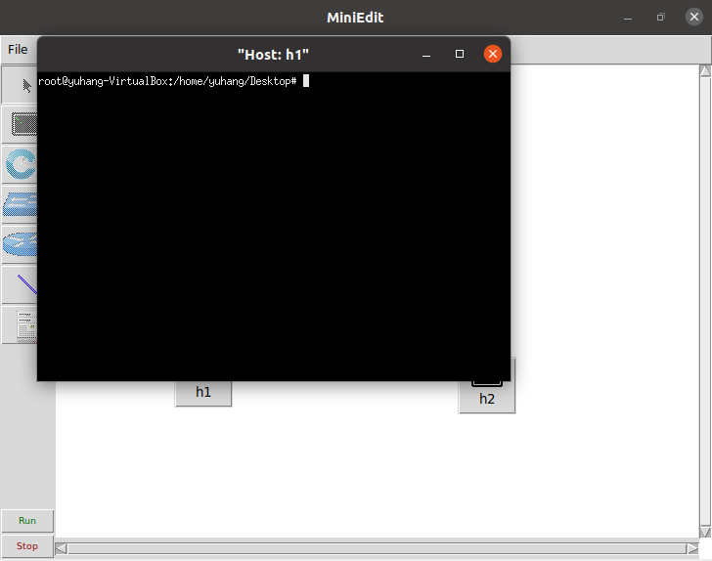

Step 2.

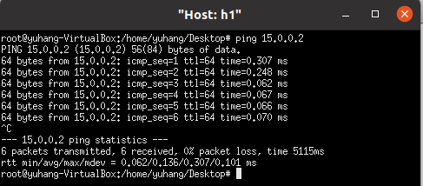

3.

3.1

Step 1.

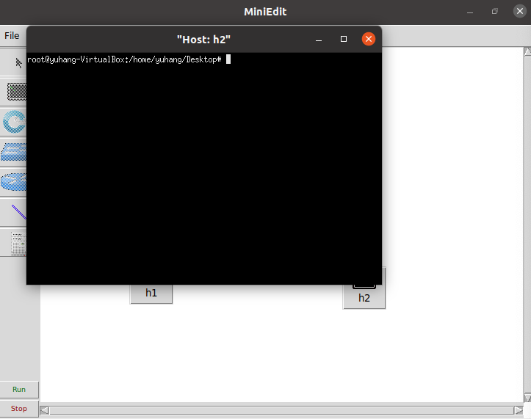

Step 2.

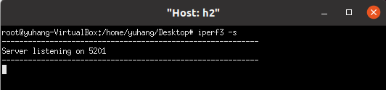

Step 3.

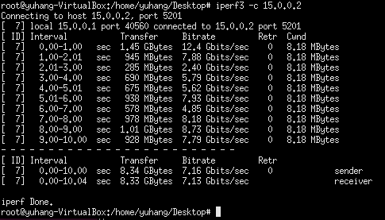

Step 4.

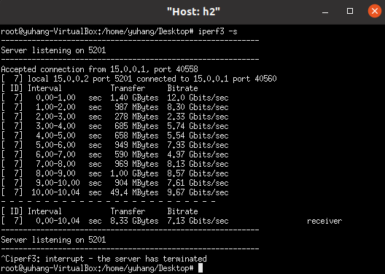

3.3

Step 1.

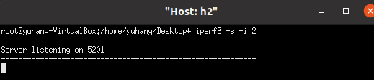

Step 2.

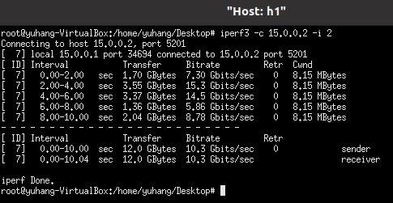

Step 3.

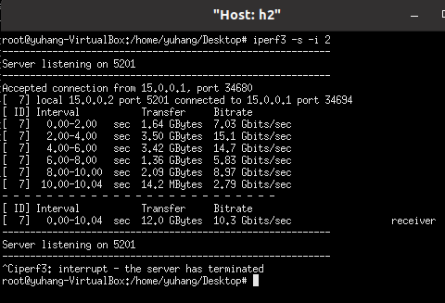

3.4

Step 1.

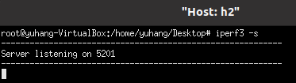

Step 2.

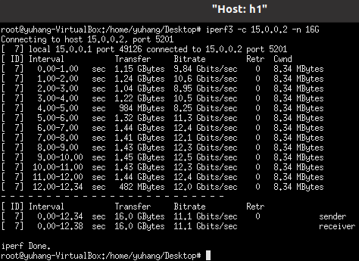

Step 3.

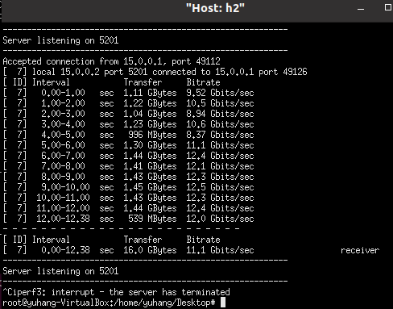

3.5

Step 1.

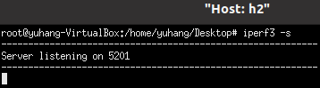

Step 2.

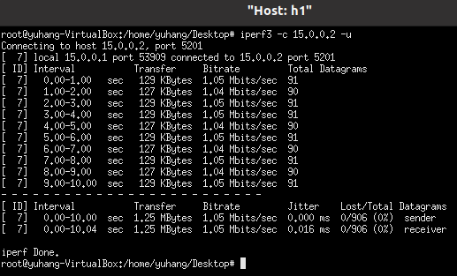

Step 3.

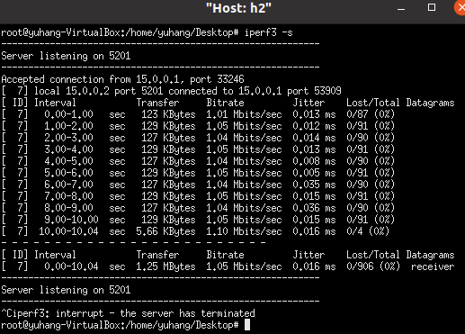

3.6

Step 1.

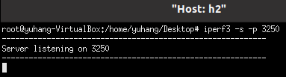

Step 2.

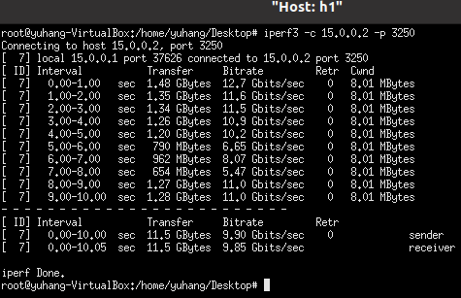

Step 3.

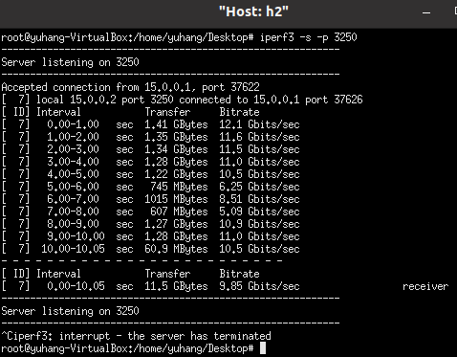

3.7

Step 1.

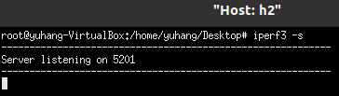

Step 2.



Step 3.

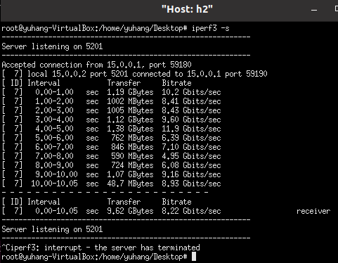

3.8

Step 1.

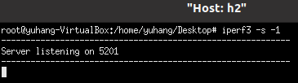

Step 2.

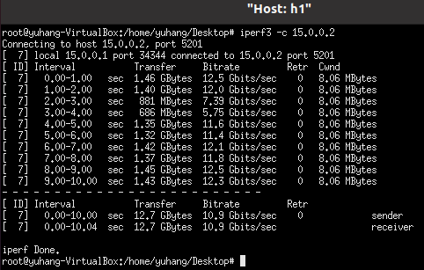

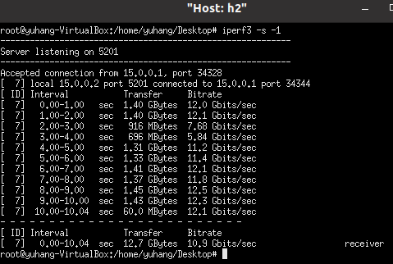

4.

Step 1.

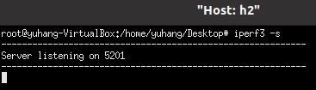

Step 2.

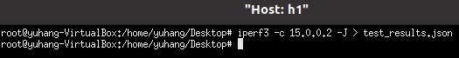

Step 3.

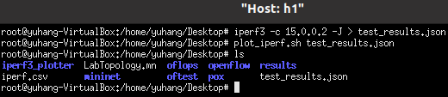

Step 4.

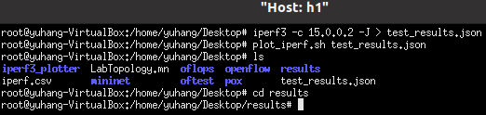

Step 5.















Step 6.

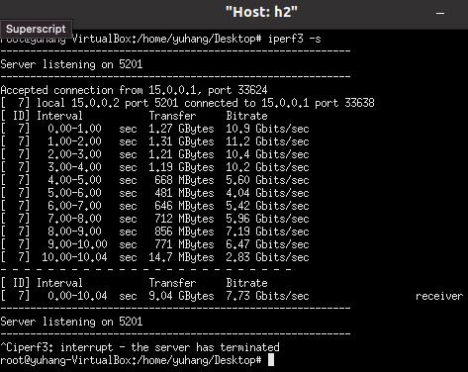

Conclusion

This report explored Mininet and iPerf3. Mininet is a virtual testbed used for testing network tools and protocols. The first lab invoked Mininet from the command-line interface (CLI) utility and used Miniedit to construct, emulate and save a self-defined network topology. It showed how powerful Mininet is to design your own network for testing. The second lab used iPerf3 to measure and test the designed network topology coming from the first lab. Different options from the command line utility are explored, such as intervals, port number, protocols and etc., to better understand its functionality. Through this report, Mininet and iPerf3 are well understood and hands-on experiences are acquired.